[This template is for the "Journal of Pediatric Nephrology"]

“Article Type: Review Article”

The title of paper, Capitalize first letters

(18 pt, Bold, Times New Roman)

First Author¹ (First name Sure name), Second Author², Third Author^{3*}, …

(10 pt, Bold, Times New Roman)
¹ Affiliation (Department, School/College, Institution/University, City/State-Country)
….
….

Authors' name: Sure name and first letter of First name.

Corresponding Author(s):

Name:

Email Address (Academic email address is preferred):

Phone No. (Available number for emergency calls):

ORCID ID:

Abstract
(10 pt, Times New Roman)
Please provide an abstract, not to exceed 500 words; with no citations, references, or undefined abbreviations. It should contain following parts:
Abstract
[Add text for this section of the manuscript]

Keywords: 3-5 keywords related to the article separated with semicolon (;), At least 3 of them should be based on MeSH. (10 pt, Times New Roman).
Samples:

Keywords: Pyelonephritis; Ultrasonography; Child; Kidney Diseases, Cystic;

Keywords: [Add text for this section of the manuscript]

Main Text
(Headings: 12 pt, text: 11 pt) References should be numeric and in parentheses: (1). Do not use tabs or indents to start a paragraph

Introduction
Introduction should clearly state the problem, introduce relevant literature, note any controversies, It may contain subheadings; insert reference format using Endnote based on Vancouver style. (11 pt, Times New Roman, single line space).
Abbreviations
Abbreviations should be defined at first mention and used consistently thereafter.

[Add text for this section of the manuscript]

Conclusion
Should be brief and clearly state how the findings of the study relate to the underlying aims/hypothesis and the implication of the research.

[Add text for this section of the manuscript]

Acknowledgements
Include contributions from non-authors. This may include administrative and technical support, or donations in kind

[Add text for this section of the manuscript]

Conflict of Interest
Declare conflicts of interest or state “The authors declare no conflict of interest.” Authors must identify and declare any personal circumstances or interest that may be perceived as inappropriately influencing the representation or interpretation of reported research results. Any role of the funders in the design of the study; in the collection, analyses or interpretation of data; in the writing of the manuscript, or in the decision to publish the results must be declared in this section. If there is no role, please state “The funders had no role in the design of the study; in the collection, analyses, or interpretation of data; in the writing of the manuscript, or in the decision to publish the results”.

[Add text for this section of the manuscript]

Financial Support
Please add: “This research received no external funding” or “This research was funded by NAME OF FUNDER, grant number XXX.

[Add text for this section of the manuscript]

Authors Contributions
Designate each author’s contribution using their initials.
For example: “Conceptualization, X.X. and Y.Y.; methodology, X.X.; software, X.X.; validation, X.X., Y.Y. and Z.Z.; formal analysis, X.X.; investigation, X.X.; resources, X.X.; data curation, X.X.; writing—original draft preparation, X.X.; writing—review and editing, X.X.; visualization, X.X.; supervision, X.X.; project administration, X.X.; funding acquisition, Y.Y”.

[Add text for this section of the manuscript]

References
It is highly recommend using citation management software, such as Endnote.
Vancouver style (9 pt)

Our reference style requirements are in accordance with the Uniform Requirements for Manuscripts Submitted to Biomedical Journals by the International Committee of Medical Journal Editors (ICMJE updated October 2008).
Note: List all authors when there are 6 or fewer; when there are 7 or more, list the first 6, followed by “et al.

(Author 1: Surname First character of first name, Author 2, …. Title of the article. Abbreviated Journal Name Year, Volume, page range.).

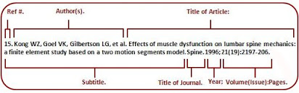

Examples:

- Journal Article
- Mohkam M, Roozrokh M. Medicine and Nephrourology in Ancient Iran: Part II: Avicenna and His Art of Uroscopy. J Ped. Nephrol 2013;1(2):41- 43.

- Books and other monographs
- Deborah P. Jones, Russell W Chesney. Nephrotoxins. In: Ellis D. Avner, William E. Harmon. Pediatric Nephrology. 6th ed. Springer. 2009. P. 1275-96

[Add text for this section of the manuscript]

Tables and diagrams:
Table should be prepare using table tool within the Microsoft word and cited consecutively in the text. Every table must have a descriptive title. All table columns should have an explanatory heading.

Table 1. Table title (10 pt)
column heading | Column A (t) | Column B (T)
First entry | 1 | 2
Second entry | 3 | 4
Third entry  … | 5 | 6

Diagrams should be inserted in their original editable format. Don’t convert them into images.

Figures: Figures and tables should be kept to a necessary minimum and their information should not be duplicated in the text. Figures must be supplied either as JPEG or TIFF. Photographs and radiological imaging must be high resolution (300 dpi or higher) and at least 10 x 10 cm large. All figures should be cited in the paper in a consecutive order as: (Figure 1)
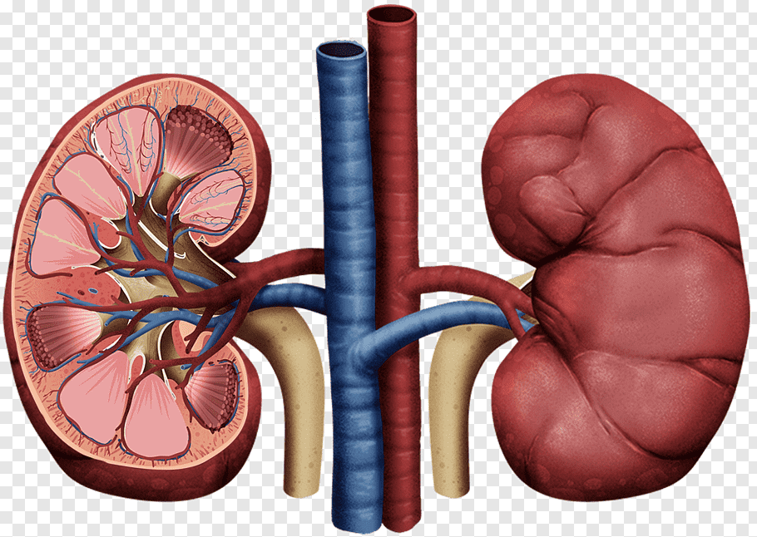
Figure 1. Figure titles (10pt)

