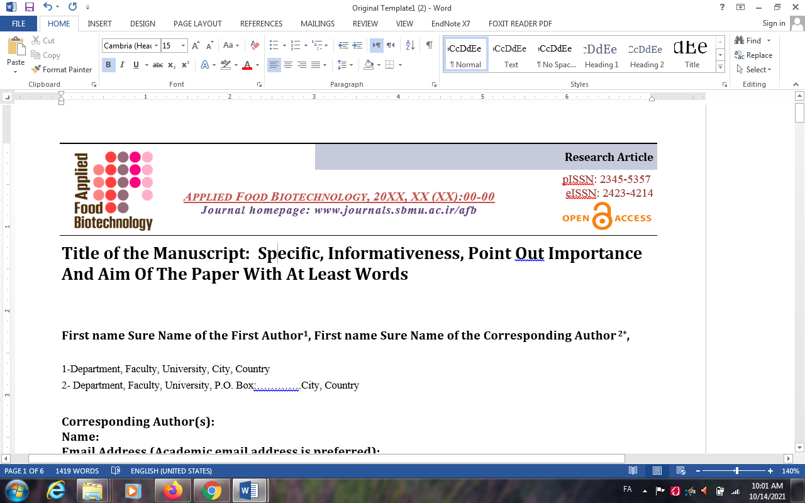

Copyright and License Agreement

Dear Prof. Khosravi
Editor-in-Chief, Applied Food Biotechnology Date:

On behalf of my co-authors, I am submitting the enclosed manuscript entitle: […………………………..…………………………………………………………………….] for consideration for publication in the "Applied Food Biotechnology".

For the submission of an 'article' to ‘Appl Food Biotechnol`, I hereby certify that:
4.1. I have been granted authorization by my co-authors to enter into these arrangements.
4.2. I hereby declare, on behalf of myself and my co-authors, that:
- The article submitted is an original work and has neither been published in any other peer-reviewed journal nor is under consideration for publication by any other journal. More so, the article contains no violation of any existing copyright, moral rights or other third party right or any material of an obscene, indecent, defamatory or otherwise unlawful nature and that to the best of your knowledge this Article does not infringe the rights of others;
- I am/we are the sole author(s) of the article and maintain the authority to enter into this agreement and the granting of rights to "Applied Food Biotechnology" does not infringe any clause of this agreement.
- I/we have taken due care that the scientific knowledge and all other statements contained in the article conform to true facts and authentic formulae and will not, if followed precisely, be detrimental to the user.
- I warrant that any formula or dosage given is accurate and will not if properly followed injure any person;
- I have made a significant scientific contribution to the study and I have read the complete manuscript and take responsibility for the content and completeness of the final surmised manuscript;
- I/we permit the adaptation, preparation of derivative works, oral presentation or distribution, along with the commercial application of the work.
- No responsibility is assumed by "Applied Food Biotechnology", its staff or members of the editorial board for any injury and/or damage to persons or property as a matter of products liability, negligence or otherwise, or from any use or operation of any methods, products instruction, advertisements or ideas contained in a publication by "Applied Food Biotechnology".
If the article has been prepared by an employee within the duration of his or her employment, the employer reserves the right to make copies of the work for its own internal use or for promotional purposes only. If the manuscript has been prepared as a work made for hire, both employer and employee should sign the copyright transfer.
If the article was prepared under the legitimate contract, the transfer of copyright is effective to the extent that such copyright is transferable. The contributor(s) affirm that the work contains no unlawful or libelous statements and opinions and liable materials of any kind whatsoever, do not infringe on any copyrights, intellectual property rights, personal rights or rights of any kind of others, and contain any materials, instructions, procedures, information or ideas that might cause any harm, damage, injury, losses or costs of any kind to person or property. The contributor(s) also represent and warrant that they have full power and authority to enter into this Agreement. I will indemnify and keep indemnified the Journal's Editor against all claims and expenses (including legal costs and expenses) arising from any breach of this warranty and the other warranties on your behalf in this agreement.

Copyright: Authors who publish in any "Applied Food Biotechnology" print & online journal will transfer copyright to their work to "Applied Food Biotechnology". Submission of a manuscript to the respective journals implies that all authors have read and agreed to the content of the Covering Letter or the Terms and Conditions. It is a condition of publication that manuscripts submitted to this journal have not been published and will not be simultaneously submitted or published elsewhere. Plagiarism is strictly forbidden, and by submitting the article for publication the authors agree that the publishers have the legal right to take appropriate action against the authors, if plagiarism or fabricated information is discovered. By submitting a manuscript the authors agree that the copyright of their article is transferred to the publishers if and when the article is accepted for publication.

Type name of corresponding author | Signature | Date

