The Effect of Ash Water on Viruses
Ishak Afşin Kariperª*, Saliha Esra Bolsu Kariper^{b}

a. Department of Education, Erciyes University, Kayseri, Turkey
b. Department of Engineering, Sivas Cumhuriyet Univerity, Sivas, Turkey

Article Info:  Received: October 2023  Accepted: November 2023  Published online:  November 2023  * Corresponding Author:  Afşin Kariper  Email: akariper@gmail.com | ABSTRACT:  This study conducted tests on various viruses with ash water, which can be obtained very simply. The study aims to produce a liquid that can block viruses and be obtained from waste combustion products, unlike disinfectants that have a place in daily life. The present study tested ash water containing methyl stearate and methyl esters, octadecenoic, octadecanoic acid, and methyl esters and their derivatives against DNA- and RNA-based viruses. Bovine Rotavirus, Bovine Coronavirus, and Parainfluenza virus-3 were used as RNA-based viruses, and Bovine Adenovirus and Bovine Herpesvirus were used as DNA-based viruses. MTT tests were conducted in the in-vitro cytotoxicity analysis of healthy cells. After the MTT tests, ash water was filtered and adjusted to pH 7.4. It was found that, when diluted at the rate of 1/32, ash water showed no harmful effect on healthy cells. In the tests against Bovine Parainfluenza virus, the compound showed no activity. In the first 24 hours, the compound was found to block the Bovine Coronavirus, one of the RNA-based viruses, by 100% at 0.01 MOI (10-6) concentration and by 50% at 0.1 MOI (10⁻⁵) concentration. In the first 24 hours, the compound was found to block Bovine Rotavirus by 100% at 0.1 and 0.01 MOI (10-4 and 10-5) concentrations and by 50% at 1 MOI (10⁻³) concentrations. The compound showed no activity in the test conducted against Bovine Herpesvirus, one of the DNA-based viruses. When tested against Bovine Adenovirus, the compound blocked the virus by 50% in the first 24 hours at 0.01 MOI (10⁻³) concentration. As a result, it has been observed that ash water, which can be easily produced instead of disinfectants containing chemicals, is effective against two viruses. It has been understood that if the studies on ash water are improved, a natural liquid effective on viruses can be developed.  Keywords: Ash water, Antiviral agents, DNA-based viruses, RNA-based viruses.
Please Cite this article as: Kariper IA, Kariper SEB. The Effect of Ash Water on Viruses. Int. Pharm. Acta. 2023; 6(1): e8.
DOI: https://doi.org/10.22037/ipa.v6i1.43641

- Introduction
Identifying compounds used for antiviral purposes and their benefits become gradually more popular. Previous studies have investigated different combinations of antiviral agents offering high levels of viral inactivation. Since some of the infectious viruses were related to cancer, the importance of these studies further increases [1-2]. For this reason, the antiviral agents are analyzed in a broad spectrum. Identifying new compounds with antimicrobial, antioxidant, anticancer, and anti-inflammatory activities besides the antiviral activity provides significant contributions to this field [3].
Microbial surface-active agents are complex molecules incorporating various chemical types such as peptides, fatty acids, phospholipids, glycolipids, antibiotics, and lipopeptides. Studies examining the biological surface-active agents have played an important role in recent years thanks to their potential use in various fields. Most biological surface-active agents used as antibacterial, antifungal, or antiviral agents should be used at very low concentrations as specified in minimum inhibitor concentration indices. The desired activity is generally specified as a high activity level at low concentrations.
Methyl-stearate and methyl esters, octadecenamids, octadecanoic acid, and their derivatives can be considered the major antiviral agents blocking viruses. In literature, it was emphasized how these chemicals and their derivatives blocked the viruses.
Methyl stearate and methyl ester compounds were reported to have antiviral and antitumor activities, but their activities and polarities were related to optimizing temperature and time [4].
In literature, oleic acid, which increases the activity of glycosylated Vitamin D-binding protein, was reported to have antiviral and antitumor activity [5].
Antibacterial, antiviral, antifungal, and anticancer activities of 9-octadecenamid and identified fatty acid derivatives were pharmacologically analyzed, and the bioactive properties of biological surface-active agents extracted from Halomonas sp BS4 were examined. The results showed it efficiently controlled the human pathogenic bacteria and White spot syndrome virus (WSSV), an important aquaculture virus. The biological surface-active agent also suppressed the proliferation of breast epithelial carcinoma cells.
Compounds of octadecanoic acid and methyl ester were reported to be critical antiviral agents, and besides that, when combined with different antiviral medicines (ribavirin), their activity increases [6].
Combining all these components at a specific concentration is a high-cost process. Moreover, which rate these components will block the viruses is another research and debate field. However, an option is combining all these components and extracting them naturally. Ashwater is one of the most important candidates for blocked viruses. However, the direct use of living cells would cause significant problems. In the present study, an oak wood was burned at 350°C. The ash of oak wood was extracted using water and then filtered. After achieving the cytotoxicity level suitable for living cells, it was tested using DNA- and RNA-based viruses. This study aimed to survey the effect of ash water on viruses. The details of the present study are as follows.

- Materials and Methods
Phosphoric acid and ammonium hydroxide were purchased in analytical grade. Also, special filters are used in the experiments, which are purified viruses.
Figure 1. The process of obtaining the ash water and testing it using viruses.
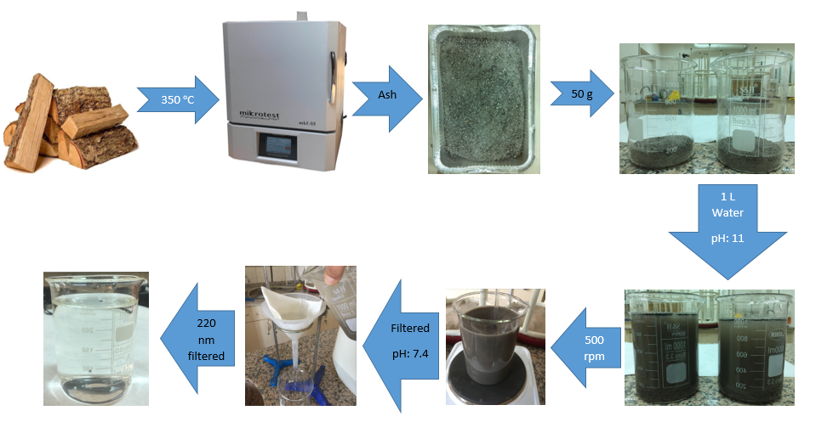

2.1 Preparation of ash water
Figure 1 presents the process of obtaining and testing the ash water using viruses. Selected oak woods were burned in an ash oven at 350°C. The ash obtained from the combustion process was left for cooling for one day and then taken to aluminum containers. The ash powder was weighed at 50g and, after being put in a beaker, it was filled to 1 liter using pure water. The ash-water mixture was mixed at 500 rpm (0.294 G) for 1 minute and left to rest for 2 hours. After a while, ash sank to the bottom. The filtering process was initiated when the pH level of the mixture reached 11; the supernatant aqueous portion was filtered through a basic two-layered filter paper. Until achieving the pH level of 7.4, 1 ml concentrated phosphoric acid was added into the clear filtrate drop-by-drop, and then 1.2 ml concentrated ammoniac was added drop-by-drop. Finally, the clear liquid was filtered through a 220 nm filter. The liquids were kept in closed tubes at room temperature until the tests. The component analyses of liquids were performed using a GC/MS device.
2.2 GC/MS Analysis
The content analysis of decayed products was conducted using GC/MS QP2010 Gas Chromatograph Mass Spectrometer (Shimadzu) (Carrier gas: helium, column: 5SMS restek). The methods specified in the literature were used in analyses performed within the scope of the present study. The settings in the GC process were as follows: column oven temperature: 100ºC, injection temperature: 275ºC, and sampling time: 0.5 minutes. In the MS part, the settings were as follows: ion source temperature: 280ºC, interface temperature: 280ºC, and solvent cut time: 2.55 minutes. The measurements were performed using these parameters as reported in the literature [5-6].
2.3 Cell cultures
In preliminary studies, the cytotoxicity of oak water was analyzed, and the viral inactivation experiments for antiviral purposes were performed using MA104 and MDBK (Figures 2 and 3) cell lines. In the reproduction of cell cultures, 10% inactivated conventional bovine serum (FBS) and DMEM (Dulbecco’s Modified Eagle Medium) that contains 100 U/ml Penicillin-100 mg/ml Streptomycin (PanReac AppliChem) were used. Cell density measurements were performed using Ahiler 8453 diode array spectrophotometer by reading the absorbance at 570 nm wavelength. Microscope images were obtained using Olympus inverted microscope CZX41 at X40 magnification.
Figure 2. cytotoxicity of oak water.
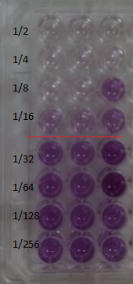

2.4 Viruses
The antiviral activity of Oak Water was analyzed using Bovine Rotavirus (Figure 3), Bovine Coronavirus, Parainfluenza virus-3 as RNA-based virus, and Bovine Adenovirus and Bovine Herpesvirus (Figure 4) as DNA-based virus. Viruses obtained from faculty of veterinary medicine laboratories, Erciyes University, Kayseri, Türkiye. MA104 cell culture was used in Bovine Rotavirus tests, and MDBK cell culture was used in tests of other viruses. After the titration tests of viruses, MOI calculation was performed to determine the DKID50 values.
2.5 In-vitro Cytotoxicity Study
For this purpose, MA104 (ATCC CRL-2378) and MDBK (ATCC CCL-22) cells were diluted for testing Ash Waters at 2x10⁵ cells/ml. Then, 96-well culture plates were prepared by adding 100 μl (1x10⁴ cells) from the dilutions in each well. The plates were incubated at 37 °C for 24 hours in a 5% CO2 incubator to achieve a monolayer coating. The compound was diluted using serum-free DMEM in the Log 2 base. The media in plate wells were then aspirated. After washing with PBS, the dilutions were added into three wells for each dilution (100μl in each). After repeating the incubation, the cytotoxic analyses were performed at the end of 24 hours. In the preliminary analysis, in which the inverted tissue culture was examined using a microscope, it was determined that the compound was cytotoxic at the rate of 1/16 for both MA104 and MDBK cells. Similar results were achieved in the cytotoxicity analysis performed using the MTT test (Figure 2). In all the antiviral tests, the compound was used at a 1/32 dilution rate, which was not cytotoxic (Figure 2).
2.6 MTT ((3-(4,5-dimethylthiazol-2-yl)-2,5-diphenyltetrazolium bromide) Analysis
Figure 3. Oak water dilutions in Log 2 base.
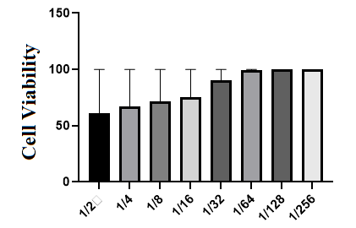

In MTT analyses, the culture media were removed from the environment, and the wells were rinsed twice using 200 μl phosphate-buffered saline solution (PBS) and, by adding ten μl MTT and 100 μl DMEM at 5mg/ml concentration in each well, they were incubated at 37 °C for 4 hours. Then, the media were removed and incubated for 30 minutes using 50μl DMSO. The absorbance was read at 570 nm wavelength (Figure 3), and the results were parallel with those obtained with an inverted microscope to determine the amount of formazan crystal (Figure 2). In all the antiviral tests, the non-cytotoxic 1/32 compound solutions were used (Figure 3).
2.7 Viral Inactivation Test
MA104 and MDBK cells were incubated in 96-well plates (1x10⁴ cells in each well) for 24 hours at 37 °C using a 5% CO₂ incubator. Viruses were diluted in Log 10 base, and 100 μl from dilutions were added into four wells for each dilution and incubated for 1 hour. Then, the inoculum was removed at the end of the process, the surface was rinsed with PBS, and the compound sample was diluted at 1/32; 100 μl was added into each well, and the incubation was repeated under the same conditions. Inverted microscope evaluations were performed in 24th, 48th, and 72nd hours.
- Results and Discussion
Table 3: Bovine Parainfluenza virus 3 CPE.
Log 10 | Bovine Parainfluenza virus 3
Log 10 | Compound Sample (hours) |  |  | Virus Control (hours)
Log 10 | 24 | 48 | 72 | 24 | 48 | 72
10^{-1, -6} | 4/4 | 4/4 | 4/4 | 4/4 | 4/4 | 4/4
10⁻⁷ | 4/4 | 2/4 | 2/4 | 4/4 | 4/4 | 4/4
10⁻⁸ | 2/4 | 2/4 | 2/4 | 2/4 | 2/4 | 2/4

The analyses were performed by examining the cytopathic activity (CPE) of the virus in 4 wells for each well by using an inverted microscope. After the antiviral analyses, it was determined that the compound activity on viruses with RNA at the end of 24 hours was higher than for the viruses with DNA. In general, it was observed that CPE values in wells increased on 48th and 72nd hours. The assessments were performed considering the activity in the first 24 hours.
Table 4: Bovine Herpesvirus CPE.
Log 10 | Bovine Herpesvirus
Log 10 | Compound Sample (hours) |  |  | Virus Control (hours)
Log 10 | 24 | 48 | 72 | 24 | 48 | 72
10^{-1, -6} | 4/4 | 4/4 | 4/4 | 4/4 | 4/4 | 4/4
10⁻⁷ | 4/4 | 4/4 | 4/4 | 2/4 | 3/4 | 4/4
10⁻⁸ | 1/4 | 1/4 | 1/4 | 0/4 | 1/4 | 2/4

At the end of the first 24 hours against Bovine Coronavirus, which is one of the RNA-based viruses, it was determined that the compound blocked the virus by 100% when at 0.01 MOI (10-6) concentration and by 50% when at 0.1 MOI (10-5) concentration (Table 1).
Table 1: Bovine Coronavirus CPE.
Log 10 | Bovine Coronavirus
Log 10 | Compound Sample (hours) |  |  | Virus Control (hours)
Log 10 | 24 | 48 | 72 | 24 | 48 | 72
10^{-1, -4} | 4/4 | 4/4 | 4/4 | 4/4 | 4/4 | 4/4
10⁻⁵ | 1/4 | 4/4 | 4/4 | 4/4 | 4/4 | 4/4
10⁻⁶ | 0/4 | 2/4 | 2/4 | 4/4 | 4/4 | 4/4
10⁻⁷ | 0/4 | 0/4 | 0/4 | 4/4 | 4/4 | 4/4
10⁻⁸ | 0/4 | 0/4 | 0/4 | 2/4 | 2/4 | 2/4

At the end of the first 24 hours against Bovine Rotavirus, it was determined that the compound blocked the virus by 100% when at 0.1 and 0.01 MOI (10-4 and 10-5) concentrations and by 50% when at 1 MOI (10-3) concentration (Table 2).
Table 2: Bovine Rotavirus CPE.
Log 10 | Bovine Rotavirus
Log 10 | Compound Sample (hours) |  |  | Virus Control (hours)
Log 10 | 24 | 48 | 72 | 24 | 48 | 72
10⁻¹ | 4/4 | 4/4 | 4/4 | 4/4 | 4/4 | 4/4
10⁻² | 4/4 | 4/4 | 4/4 | 4/4 | 4/4 | 4/4
10⁻³ | 2/4 | 4/4 | 4/4 | 4/4 | 4/4 | 4/4
10⁻⁴ | 0/4 | 2/4 | 4/4 | 4/4 | 4/4 | 4/4
10⁻⁵ | 0/4 | 1/4 | 4/4 | 4/4 | 4/4 | 4/4
10⁻⁶ | 0/4 | 0/4 | 4/4 | 2/4 | 4/4 | 4/4
10⁻⁷ | 0/4 | 0/4 | 2/4 | 0/4 | 2/4 | 2/4
10⁻⁸ | 0/4 | 0/4 | 0/4 | 0/4 | 0/4 | 0/4

In the test against Bovine Parainfluenza virus, the compound showed no activity (Table 3). Among the DNA-based viruses, the compound was found to have no activity against Bovine Herpesvirus (Table 4).
In the test against Bovine Adenovirus, in the first 24 hours, the compound was found to block the virus by 50% when at 0.01 MOI (10-3) concentration (Table 5).
The GC/MS results of samples coded with OAK are presented in table 5.
Table 5: Bovine Adenovirus CPE.
Log 10 | Bovine Adenovirus
Log 10 | Compound Sample (hours) |  |  | Virus Control (hours)
Log 10 | 24 | 48 | 72 | 24 | 48 | 72
10^{-1, -2} | 4/4 | 4/4 | 4/4 | 4/4 | 4/4 | 4/4
10⁻³ | 2/4 | 4/4 | 4/4 | 2/4 | 4/4 | 4/4
10⁻⁴ | 0/4 | 4/4 | 4/4 | 1/4 | 4/4 | 4/4
10⁻⁵ | 0/4 | 2/4 | 2/4 | 0/4 | 2/4 | 2/4
10^{-6, -8} | 0/4 | 0/4 | 0/4 | 0/4 | 0/4 | 0/4

Given the results of GC-MS analyses, the composition was found to be: 26.97% Methyl stearate, 20.03% oleic acid, 17.6% (9)-Octadecenamide, (Z)- (CAS)-Octadecanoic acid, 12.38% (10)-Octadecenoic acid, methyl ester, 8.08% Hexadecanoic acid, methyl ester, 2.36% (1,2-15,16-) Diepoxyhexadecane, 2.26% Tricosanoic acid, methyl ester, and 2.27% Methyl tetradecane. GC-MS chromatogram is presented in figure 4 (11).
The antiviral properties of oleic acid and its derivatives were examined in many studies. The results reported in the literature determined that oleic acid strengthened when combined with proteins such as α-lactalbumin and lactoferrin. The structure showing antitumor activity in both in vivo and in vitro analyses is based on “oleic acid-protein complexes” to examine the chemical activities of these proteins [7-8].
For another biologically active material, the fatty acid profile of which was investigated, the material’s anti-HRSV activity originated from its oleic acid and derivative contents, and it was reported that an increase in the concentration of active ingredient also increased the inhibition [9]. The present results suggest that the antiviral activity of the compound originates from the high concentration of oleic acid content.
Figure 4 GC-MS chromatogram.
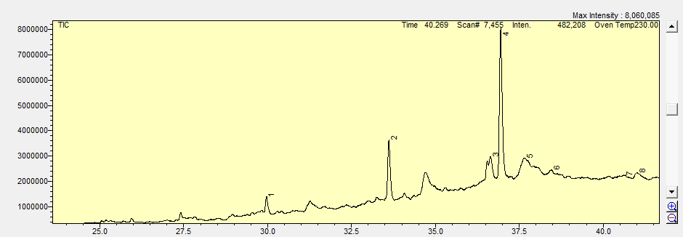

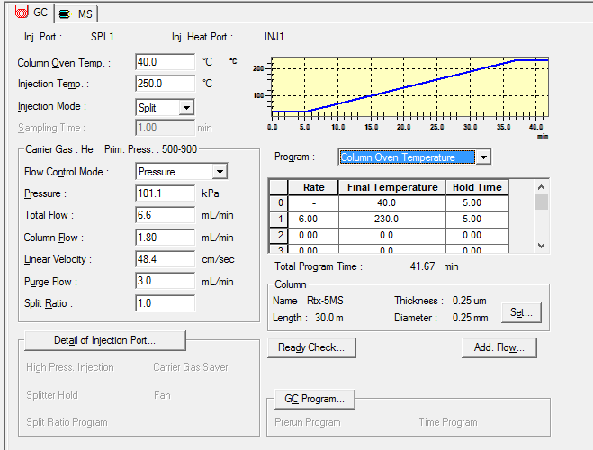

In previous studies, the antitumor-antivirus activity of methyl stearate compound was investigated, and it was asserted that the results were promising. The physiological salts of methyl esters of methyl groups, the antiviral effects investigated against various viruses, were reported to have strong antiviral activity [10-11]. The effects of methyl groups isolated by extracting from different plants on human-transmitted viruses and bacteria were examined. They were found to have strong antiviral and antibacterial effects and were reported to provide inhibition when at minimum concentration [12]. The antiviral activity of methyl stearate compounds isolated from different sources and identified using gas chromatography-mass spectroscopy was emphasized in a previous study, and it was also reported that they have important antimicrobial activity and anti-proliferative effects on Streptococcus mutans [13].
Stearic acid, methyl ester, or stearate, is a compound with 19 saturated carbon chains known as octadecanoic acid methyl ester. In previous studies, it was reported that fatty acids showed various antiviral activity against viruses, inhibited the replication of HCV, and showed synergy with IFN-α [14]. The activity of the combination of octadecanoic acid, methyl ester, and ribavirin on the measles virus was investigated, and it was reported that both compounds could be combined with commercially available medicines such as ribavirin to achieve high levels of antiviral activity when at lower concentrations [6]. The inhibition effect of oleic acid (17.6%) and methyl esters (12.38%) on the viruses, observed in the present study using gas chromatography–mass spectrophotometer, is in corroboration with the results reported in the literature.
Hexadecanoic acid is also known as palmitic acid, and it was reported in previous studies that this compound has significant antioxidant and antimicrobial effects besides antiviral activity. It was also reported to have antiviral activities, especially on Coxsackievirus B [15]. Moreover, hexadecanoic acid was reported to have moderate antiviral activity [16]. The antiviral activity of hexane extracts can be explained by hexadecanoid acid (palmitic acid), asserted to have antibacterial and antiviral effects under specific conditions [17]. In parallel with the literature, it was determined in the present study that hexadecanoic acid, which was found to be at 8.08% concentration in the present study, showed inhibition capacity in all the investigated viral parameters at different concentrations.
In conclusion, the antiviral capacity of oak water compound, which incorporates different biologically active components in its structure, was investigated using different viruses. The difference from the results reported in the literature is believed to be because of the methodological difference and the microbial loads used. Besides that, the antiviral effects of various bioactive compounds, which incorporate this biologically and chemically active component, on different viruses have been identified to a large extent.
4. Conclusion
The present study investigated the effects of ash water, a combustion product, on different RNA and DNA-based viruses. Regarding the RNA-based viruses, the ash water was effective against Bovine Coronavirus and Bovine Rotavirus but not against Bovine Parainfluenza virus. Considering the DNA-based viruses, the compound showed no activity in the test against Bovine Herpesvirus but was effective against Bovine Adenovirus. The present study showed that ash water may block the RNA- and DNA-based viruses and can potentially be used as a liquid serum. Moreover, the composition of ash water may vary depending on various parameters such as stirring time, speed, and temperature. Thus, this aspect should be further examined, and future studies should conduct tests including these parameters.
Moreover, animal experiments will be conducted in our next study. The next studies will obtain the ash water from various parameters such as stirring time, speed, and temperature. Then, the obtained liquid will also test for the viruses. Furthermore, the ash water will test for human viruses.
Acknowledgments
None.
Conflict of interest
There is no conflict of interest.
Ethics
None.
Authors' ORCIDs
Ishak Afşin Kariper:
https://orcid.org/0000-0001-9127-301X
Saliha Esra Bolsu Kariper:
https://orcid.org/0000-0001-9470-169X
References
[1] Karakuş S, Küçükgüzel, ŞG, Küçükgüzel, İ, De Clercq E, Pannecouque C, Andrei G, Bayrak ÖF. Synthesis, antiviral and anticancer activity of some novel thioureas derived from N-(4-nitro-2-phenoxyphenyl)-methanesulfonamide. Eur. J. Med. Chem. 2009;44(9): 3591-5.
[2] Küçükgüzel I, Tatar E, Küçükgüzel ŞG, Rollas S, De Clercq E. Synthesis of some novel thiourea derivatives obtained from 5-[(4-aminophenoxy) methyl]-4-alkyl/aryl-2, 4-dihydro-3H-1, 2, 4-triazole-3-thiones and evaluation as antiviral/anti-HIV and anti-tuberculosis agents. Eur. J. Med. Chem. 2008;43(2):381-92.
[3] Kulabaş N, Bingöl Özakpınar Ö., Özsavcı, D, Leyssen P, Neyts J, Küçükgüzel İ. Synthesis, characterization and biological evaluation of thioureas, acylthioureas and 4-thiazolidinones as anticancer and antiviral agents. MARMARA Pharm. J. 2017;21(2):371-84.
[4] Meng Z, Gao X, Yu H, Zhang L, Yu X, Zhao L. Compatibility of rubber stoppers for recombinant antitumor-antivirus protein injection by gas chromatography-mass spectrometry. J. Pharm. Anal. 2019;9(3):178-84.
[5] Thyer L, Branca JJ, Taubmann M. Clinical experience of immunotherapy based on oleic acid bound to glycosylated vitamin D-binding protein in localised and metastatic adenocarcinoma of the pancreas. Anticancer Res. 2014;34(10):5847-49.
[6] Linton REA, Jerah SL, Bin Ahmad I. The effect of combination of octadecanoic acid, methyl ester and ribavirin against measles virus. Int. J. Sci. Tech. Res. 2013;2(10):181-4.
[7] Fang B, Zhang M, Tian M, Jiang L, Guo HY, Ren FZ. Bovine lactoferrin binds oleic acid to form an anti-tumor complex similar to HAMLET. Biochim Biophys Acta. 2014;1841(4):535-43.
[8] EmmaWard R, Branca JV, Noakes D, Morucci G, Thyer L. Clinical experience of cancer immunotherapy integrated with oleic acid complexed with de-glycosylated vitamin D binding protein. Am. J. Immunol. 2014;10(1):23-32.
[9] Doğan HH, Türkçetin Y, Duman R. Evaluation of in vitro antiviral activity of cultured pleurotus ostreatus against human respiratory syncytial virus (HRSV). J. Fungus. 2020;11(2):172-80.
[10] Colomer R, Lupu R, Papadimitropoulou A, Vellón L, Vázquez-Martín A, Brunet J, Fernández-Gutiérrez A. et al. Giacomo Castelvetro’s salads. Anti-HER2 oncogene nutraceuticals since the 17th century? Clin. Transl. Oncol. 2008;10:30–4.
[11] Dahl TC, Menning MM, Oliyai R; Gilead Sciences Inc., Compositions and methods for combination antiviral therapy. United States Patent US 8,592,397. 2013 Nov. 26.
[12] Khiralla A, Spina R, Varbanov M, Philippot S, Lemiere P, Slezack-Deschaumes S, Philippe A, et al. Evaluation of Antiviral, Antibacterial and Antiproliferative Activities of the Endophytic Fungus Curvularia papendorfii, and Isolation of a New Polyhydroxyacid. Microorganisms. 2020;8(9):1353.
[13] Huang CB; George B; Ebersole JL. Antimicrobial activity of n-6, n-7 and n-9 fatty acids and their esters for oral microorganisms. Arch. Oral. Biol. 2010;55:555–60
[14] Leu GZ, Lin TY, Hsu JT. Anti-HCV activities of selective polyunsaturated fatty acids. Biochem. Biophys. Res. Commun. 2004;318(1):275-80.

