The esthetic crown lengthening by Er,Cr:YSGG laser : A case series
Reza Fekrazad ¹, Mohammad Moharammi ², Nasim Chiniforush ³
¹ Laser Research Center in Medical Sciences (LRCMS), Department of Periodontics, Faculty of Dentistry, AJA University of Medical Sciences, Tehran, Iran.
² Tehran University of Medical Sciences, Tehran, Iran.
³ Laser Research Center of Dentistry, Dentistry Research Institute, Tehran University of Medical Sciences, Tehran, Iran.
Corresponding author: Nasim Chiniforush
DDS, PhD candidate, Laser Research Center of Dentistry, Dentistry Research Institute, Tehran University of Medical Sciences, Tehran, Iran.
Email: n-chiniforush@farabi.tums.ac.ir
Tel/ Fax: +98 21 88994824

Abstract:
Introduction: Laser technology as new modality in dentistry has gained special attention.. Among different types of lasers, Erbium lasers have gained special attention for management of oral soft and hard tissue simultaneously. This study present series of cases of crown lengthening and restorations accomplished by Er,Cr:YSGG.
Case Reports: Seven patients were selected for this study. After complete oral examination and diagnosis, the treatment plan of each patient was designed. All cases needed esthetic crown lengthening. In some cases, frenum revision and class V cavity preparation was done by Er;Cr:YSGG laser. All patients treated with Er,Cr:YSGG Laser producing a wavelength of 2780nm (Biolase, Irvine, California, USA)); Tip T46 mm long, 400 µm Diameter for soft tissue management and Tip G6, 6 mm long, 600 µm diameter for hard tissue management.
Results: All patients reflected acceptable results based on clinical evaluation and patients' declaration of post-surgical status.
Conclusion: Using Er, Cr:YSGG laser in class v cavity preparation and flapless crown lengthening seemed to be effective and beneficial.

KEYWORDS: Er;Cr:YSGG laser, Crown lengthening, Esthetic, Frenectomy, Cavity.

Introduction
The modern dentistry is based on safety and minimum invasive procedures. In order to achieve this goal new instruments and materials have been developed ¹. One of these newly developed instruments is lasers which come in handy in many fields of dentistry like dental bleaching, crown lengthening, restoratives, endodontic and implant surgeries ²⁻⁴ .
Several lasers and different wavelengths have been developed for cavity preparations instead of conventional technique performing by rotary instruments which do the hard tissue cutting based on biological and mechanical principles. Some advantages are named for lasers over rotary drills such as; safety, pain reduction, comfortably, reduction of noise and vibrations ⁴⁻⁷. In order to gain these benefits and optimum efficacies, some clinical studies have suggested yttrium-aluminum-grant (Er:YAG) and erbium, chromium: yttrium-scandium-gallium-garnet (Er, Cr:YSGG) lasers for cavity preparation ⁸.. Er, Cr:YSGG alongside with Er:YAG has the safest and best characteristic for precise dental procedures ⁹.
Recent studies and experiments mostly focused on usage of Er, Cr:YSGG in cavity preparation due to the emission of 2.78 µm wavelength. It is absorbed perfectly by water and hydroxyapatite which form the most percentage of bone and dentin; the subsequent reactions let ablation of bone tissues and tooth ⁸. There are several reasons for choosing Er;Cr:YSGG laser in restorative dentistry; among those the important factor which attract clinicians to choose Er, Cr:YSGG seems to be its subtle selectivity in removing carries. Caries contain larger amount of water in comparison with healthy dentin, thus, the irradiations are better absorbed by caries and make the selective removal possible ⁸; in most cases no need for anesthesia, no adverse reaction, patients satisfaction and good prognosis are other advantages mentioned for Er;Cr:YSGG¹⁰.
Besides the proven benefits of Er;Cr:YSGG laser in cavity preparation and remarkable results in hard tissues management, it is also an appropriate instrument for soft tissue surgeries like the exposure of unerupted teeth, lingual and maxillary frenectomies, gingivectomy, excision of pyogenic granuloma and pulpotomy ¹¹. In some case series, acceptable flapless crown lengthening has been demonstrated as well ¹². It is shown that using this laser can do effective, minimally invasive operations and help soft tissue management during restorative procedures ¹³.
There are several indication for crown lengthening; aesthetic enhancement by correcting and modifying surplus gingiva display and bone referred as "gummy smile"; revealing adequate tooth structure for restorative treatments of fractured teeth and removing subgingival carries^{14,15}, however, there are some contraindications for its usage as well like teeth with high furcations and endangerment of stability in cases of excessive osseous resections due to unacceptable crow-root ratio¹⁶. When a clinician intends to do soft tissue crown lengthening, it should be keep in mind not to violate biological width; in cases which there is less than 3mm of attached gingiva apically positioned flap must be considered as an alternative; in these cases gingivectomy results in complete removal of attached gingiva ¹⁴.
Crown lengthening can be accomplished by scalpel, electrosurgery, bur or lasers, in cases of external beveling lasers can be a suitable choice. Also, hard tissue can be removed in minimally invasive manner. In that case, the surgery cause little bleeding thus make it possible to handle the final restoration in a dry field which leads better results ¹⁷.
Due to mentioned features of lasers for soft and hard tissue managment, this study present series of cases of crown lengthening and restorations accomplished by Er,Cr:YSGG.
Methods and material
6 female and 1 male patients c for crown lengthening (CL) and composite restorations of anterior teeth aged between 20 to 60, were selected for this study. The patients referred to private practice for aesthetic reasons. They were unhappy with their smile and demanded consultant, thus, laser treatment was been suggested. Patients had no specific local or systemic disease which could affect teeth or gingiva. The patients had no previous treatment on current teeth. Prior to the surgery patient photos were analyzed and for those who needed CL, the approximate location of new gingiva was defined with respect to gingival margin and bone to maintain acceptable biological width; the finish point of surgery and the new location of gingival margin did not trespass cement enamel junction (CEJ). Patients' oral hygiene and periodontal health were evaluated as well.
All patients treated with Er,Cr:YSGG Laser producing a wavelength of 2780nm (Biolase, Irvine, California, USA)); Tip T46 mm long, 400 µm Diameter for soft tissue management and Tip G6, 6 mm long, 600 µm diameter for hard tissue management. Under local anesthesia (Xylocaine 2% with Adrenaline (Epinephrine) 1:200,000). The area of operation was dried and Gingivectomy was performed carefully following the curvature of the marginal crest. The margin then contoured using the same tip. No periodontal dressing was used to cover the area of operation. Patients were prescribed to not to brush surgical area and use warm normal saline for cleaning.
Cases

Patient 1: 32 year-old female patient with carries existing on buccal surface of tooth 12 and 13. The teeth were sensitive during brushing and the patient was unhappy with her smile. The soft tissue was removed by Er; Cr:YSGG laser with output power of 1.5 W, 20 Hz, 20% water/ 30% air, pulse duration of 140 µs. Then, the caries were removed with Er, Cr:YSGG with output power of 3 W, 20 Hz, 50% water, 60% air, pulse duration of 140 µs.and conditioning was also done with laser with output power of 1 W, 20 Hz, 20% water/ 30% air. As it is seen no bleeding occurred and patient felt comfortable and reported no pain. The final restorative was accomplished using 3M ESPE restorative composite resin and Scotchbond™ Universal Adhesive bonding immediately after the laser therapy.
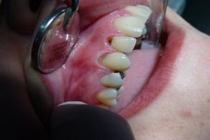 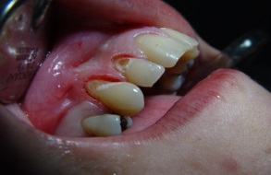 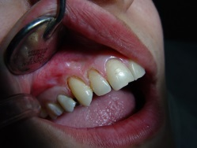 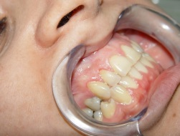1-A: pre-operative view 1-B: after carries removal 1-C: final restoration 1-D: five-year follow up
Patient 2: 21 years-old female, one-sided gummy smile, gingiva of teeth 21, 22, 23 descendent. The patient was unhappy with her smile, no pocket was detected but the bleeding was seen on probing due to hemangioma lesion which extended from buccal mucosa to depth of vestibule, the conditions of teeth were acceptable, therefore no restorative phase was needed. Gingivectomy was accomplished by Diode laser (Twilight, Biolase Technologies, USA) with wavelength of 810 nm with output power of 4 W, chopped mode with pulse duration of 20 ms and interval of 20 ms. The fiber of 400 µm was used in this patient. The patient was satisfied with the final result. No serious bleeding occurred and the patient felt little pain. She was prescribed to use warm normal saline as mouthwash.
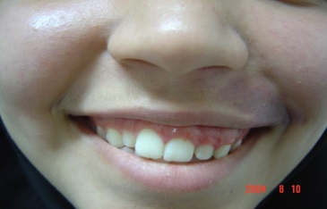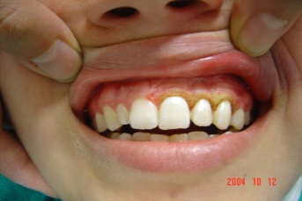
2-A: pre-operative view 2-B: post-operative view
Patient 3: 24 year-old female, two-sided gummy smile with high attached frenum. The patient was unhappy with her smile and felt her teeth are short and gingiva is too long. The patient was allergic to penicillin. There was no pocket or bleeding on probing. Clinical crown seemed shorter than the anatomical crown. As it is seen tooth 21, 22, 23, 24, 11,12, 13 and 14 needed buccal CL. Firstly the right quadrant undertook the procedure. The gingiva was removed by Er; Cr:YSGG laser with output power of 1.5 W, 20 Hz, 20% water/ 30% air, pulse duration of 140 µs. Then, the bone removal was done by output power of 3 W, 20 Hz, 50% water/ 60% air. After a week labial frenum was dissected with power of 2 W, 20 Hz, 30% water/ 45% air and crown lengthening took place on upper left quadrant with the same parameters of right quadrant. three weeks follow up indicated acceptable results; the patient was satisfied as well.
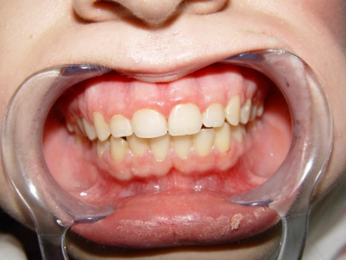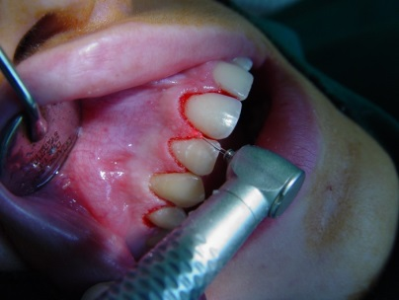
3-A: pre-operative view 3-B: crown lengthening using Er, Cr:YSGG
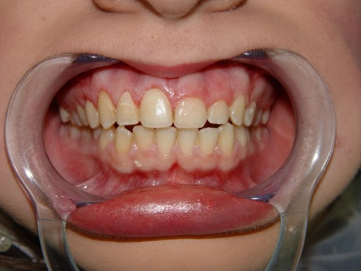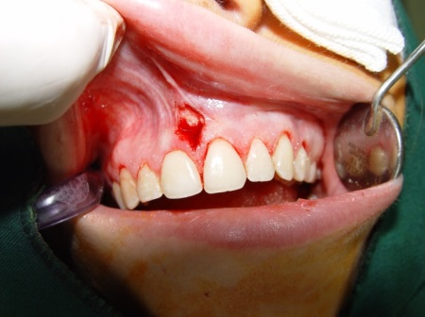
3-C: after one week 3-D: frenectomy using Er,Cr:YSGG

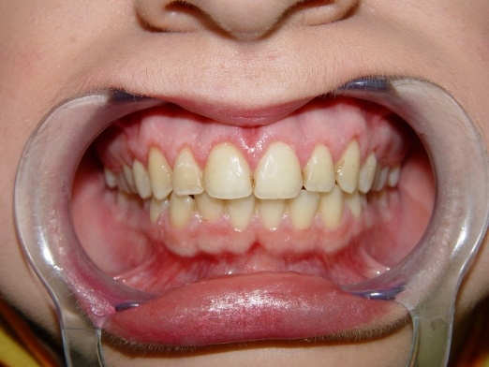
3-E: post-operative view after three weeks follow up
The CL for Patient 4 was done like patient 3. Patient 5 was a 63 year-old-man with sever attrition who underwent the same treatment plan of patient 1. Patient 6 which complaint about color of her teeth was treated by Er, Cr:YSGG laser for both soft and hard tissue and after final conditioning of teeth by laser, composite facing was done. In last case, frenectomy and crown lengthening was done by erbium laser and the crown was replaced by new one. No side effect was reported and patients' smile and aesthetics were improved significantly.

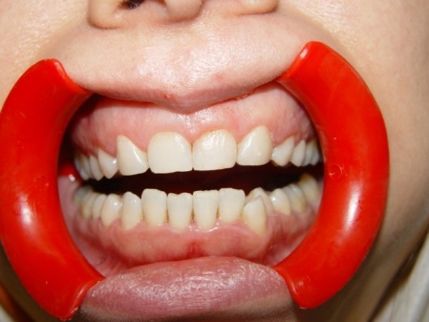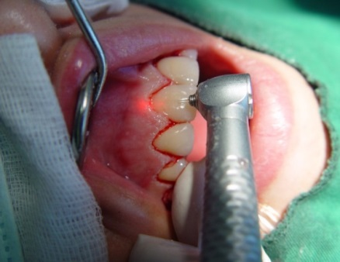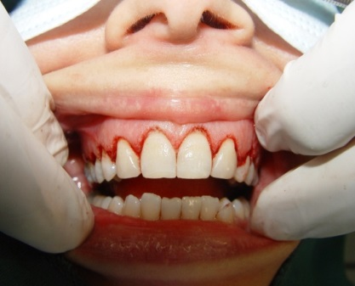
4-A: pre-operative view 4-B: CL of teeth 11, 12, 13, 14 4-D: Post-operative view
& 21, 22, 23, 24

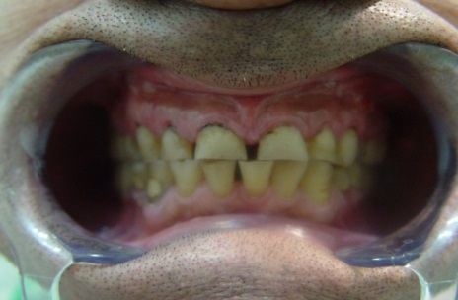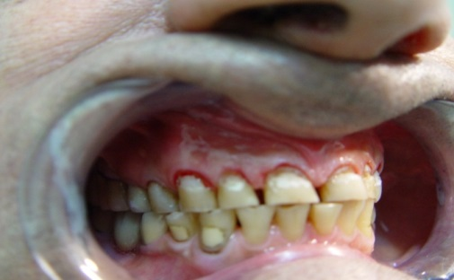
5-A: pre-operative view 5-B: CL and caries removal of teeth 13, 12, 11
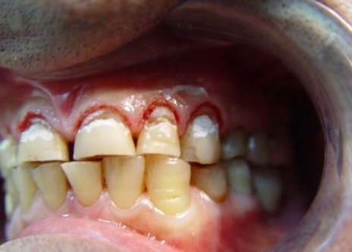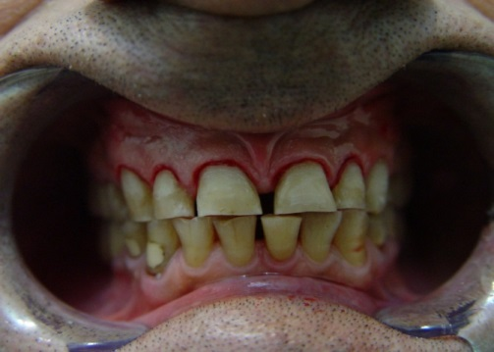
5-C: CL and caries removal of teeth 5-D: final restoration
21, 22, 23
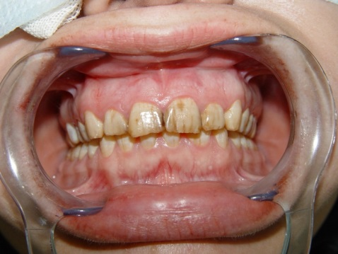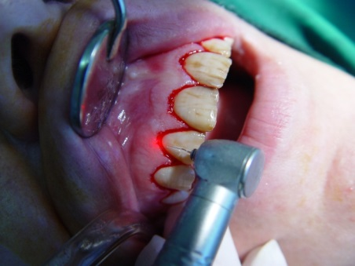
6-A: pre-operative 6-B: CL of teeth 13, 12, 11, 21, 22, 23
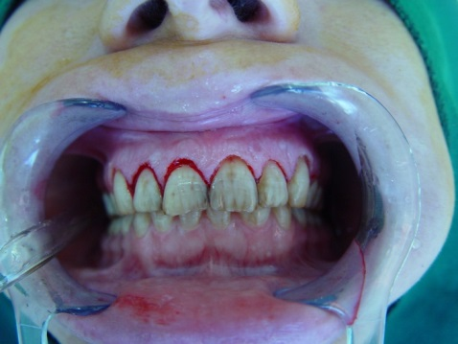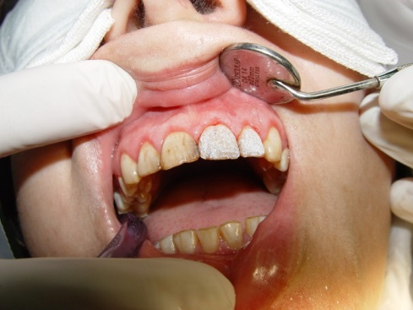
6-C: immediate post-operative 6-D: one month follow up

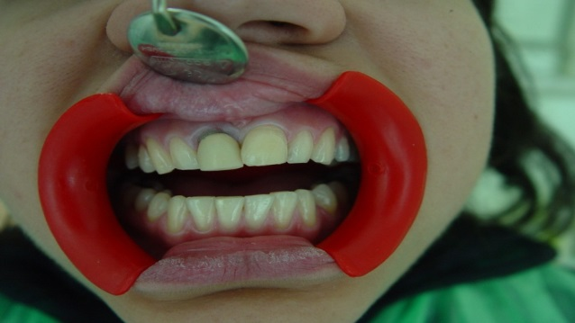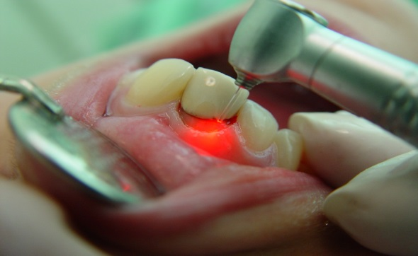
7-A: pre-operative view 7-B: CL of tooth 11
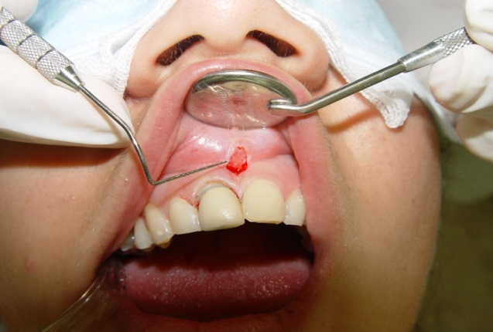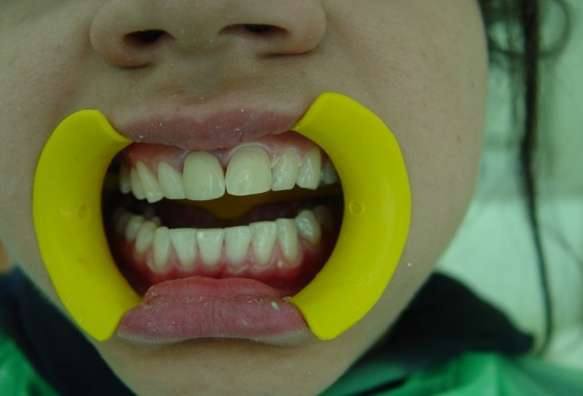
7-C: frenectomy using Er, Cr:YSGG 7-D: post-operative

Discussion
There are two main indications for crown lengthening; functional and aesthetic, each category focus on specific treatments. Aesthetic usually consider correction of short clinical crowns, improving gingival symmetry, correcting un-level gingival margins and modifying hyperplastic tissue overgrowth ¹⁸. The aesthetic procedure could be performed using traditional scalpel surgical procedures or lasers. Precision, sterilization, bloodless surgical and post-surgical course, no need for sutures, less pain and swelling and better prognosis are advantages of lasers over traditional surgeries ¹⁹.
It is also shown that both Er, Cr:YSGG and Er:YAG laser are efficient and effective for class V cavity preparation and making similar morphological features on the surfaces of operation ²⁰. Er, Cr :YSGG laser is also capable of making tooth enamel more resistant to caries by increasing its resistance against acid ²¹. However, in order to get best results and benefit from all potentials of Er, Cr:YSGG laser, some consideration must be followed like using water spray at ablation site which roles as an initiator for ablation of dental hard tissue and increases the depth of prepared cavity ²².
Er, Cr : YSGG laser is not only beneficial for adults but also showed great results for soft tissue management in children aged 6 to 14 years old were for problems like crown lengthening, exposure of an unerupted molar, lingual and maxillary frenectomies, gingivectomy, excision of a pyogenic granuloma^{11, 23}.
Up to this date, some case series studies' results showed the effectiveness and non-invasive features of lasers in the management of soft tissue ¹³ ,cavity preparation and caries removal ¹⁰. Little need of injection for hard tissue management and no need of anesthesia in soft tissue removal are the advantages of erbium laser in esthetic procedures.
In this study, Er, Cr:YSGG with water spray was served for class V cavity preparation in 2 patients, the results were satisfying as no post-operative pain or bleeding occurred and final restoration could be done immediately after preparation, no adverse effect was seen during 3 months to seven -year follow up. The aesthetic of final restoration was acceptable as well. However, the longer time spent for cavity preparation compared with conventional technique.that are enhanced by new productions.
Closed flap CL performed with Er, Cr:YSGG as well; the external bevel gingivectomy for soft tissue was chosen as appropriate technique based on sufficient attached gingiva in all cases. The final width of attached gingival was not less than 3mm. The laser bandage was performed as an additional step to accelerate healing and to reduce pain and bleeding. No suture was needed for any cases and there was no report of swelling, trauma or discomfort from any of patients. With all these saying, it must be noticed this technique cannot be done for all CL cases but it certainly helps practitioners minor surgical cosmetic cases ²⁴.
The number of references associated with flapless CL using lasers as minimally invasive procedure have increased during recent years. The majority of these studies are case reports or case series. Also, these studies are valuable but initial attempts towered demonstrating clinical advantages and capability of lasers in this field, thus prospective randomized controlled studies are needed to categorize this approach as standard procedure for CL ¹².
Having sufficient knowledge and experience regarding laser tissue interaction (soft and hard tissues) is necessary to choose the appropriate parameters, led to good prognosis. So, the application of new technology should accompanied by following basic treatment rules to achieve to best results.
Conclusion
Using Er, Cr:YSGG laser in class v cavity preparation and flapless CL seemed to be effective and beneficial; less pain, bleeding, post-operative trauma was seen and the healing time accelerated significantly.
References
1. Peters MC, McLean ME. Minimally Invasive Operative Care: II. Contemporary Techniques and Materials: an Overview. J. Adhes. Dent. 2001;3(1).
2. Lizarelli RF, Costa M, Carvalho‐Filho E, Nunes F, Bagnato VS. Selective ablation of dental enamel and dentin using femtosecond laser pulses. Laser Physics Letters. 2008;5(1):63-69.
3. Malta D, Costa M, Pelino J, de Andrade M, Lizarelli R. Bond strength of an adhesive system irradiated with Nd: YAG laser in dentin treated with Er: YAG laser. Laser Physics Letters. 2008;5(2):144-150.
4. Stübinger S. Advances in bone surgery: the Er: YAG laser in oral surgery and implant dentistry. Clinical, Cosmetic and Investigational Dentistry. 2010;2(8):47-62.
5. Keller U, Hibst R, Geurtsen W, et al. Erbium: YAG laser application in caries therapy. Evaluation of patient perception and acceptance. J. Dent. 1998;26(8):649-656.
6. Keller U, Hibst R. Experimental studies of the application of the Er: YAG laser on dental hard substances: II. Light microscopic and SEM investigations. Lasers Surg. Med. 1989;9(4):345-351.
7. Dostalova T, Jelinkova H, Kucerova H, et al. Er: YAG laser ablation: evaluation after a two-year clinical treatment. Paper presented at: BiOS'98 International Biomedical Optics Symposium1998.
8. Santos CRd, Tonetto MR, Presoto CD, Bandeca MC, Oliviera Jr O, Calabrez-Filho S. Application of Er: YAG and ER, Cr: YSGG Lasers in cavity preparation for dental tissues: A literature review. World J Dent. 2012;3:340-343.
9. Diaci J, Gaspirc B. Comparison of Er: YAG and Er, Cr: YSGG lasers used in dentistry. Review. JLAHA. 2012;1:1-13.
10. Matsumoto K, Hossain M, Hossain MI, Kawano H, Kimura Y. Clinical assessment of Er, Cr: YSGG laser application for cavity preparation. J. Clin. Laser Med. Surg. 2002;20(1):17-21.
11.Boj JR, Poirier C, Hernandez M, Espasa E, Espanya A. Case series: laser treatments for soft tissue problems in children. Eur. Arch. Paediatr. Dent. 2011;12(2):113-117.
12. McGuire MK, Scheyer ET. Laser-assisted flapless crown lengthening: a case series. Int. J. Periodontics Restorative Dent. 2011;31(4).
13. Jetter C. Soft-tissue management using an Er, Cr: YSGG laser during restorative procedures. COMPENDIUM-NEWTOWN-. 2008;29(1):46.
14. Hempton TJ, Dominici JT. Contemporary crown-lengthening therapy: a review. The Journal of the American Dental Association. 2010;141(6):647-655.
15. Levine R, McGuire M. The diagnosis and treatment of the gummy smile. Compendium of continuing education in dentistry (Jamesburg, NJ: 1995). 1997;18(8):757-762, 764; quiz 766.
16. Dibart S, Capri D, Kachouh I, Dyke TV, Nunn ME. Crown lengthening in mandibular molars: a 5-year retrospective radiographic analysis. J. Periodontol. 2003;74(6):815-821.
17. Cls CLS, Mini A. of Dental Sciences. Indian Journal of Dental Sciences. 2014.
18. Gokulanathan S, Mathews D, Daniel R, Ahathya R. Crown lengthening using diode laser: A case series. Journal of Indian Academy of Dental Specialist Researchers. 2014;1(2):77.
19. Pick RM, Colvard MD. Current status of lasers in soft tissue dental surgery. J. Periodontol. 1993;64(7):589-602.
20. Harashima T, Kinoshita J-I, Kimura Y, et al. Morphological comparative study on ablation of dental hard tissues at cavity preparation by Er: YAG and Er, Cr: YSGG lasers. Photomedicine and Laser Therapy. 2005;23(1):52-55.
21. Geraldo-Martins VR, Lepri CP, Palma-Dibb RG. Influence of Er, Cr: YSGG laser irradiation on enamel caries prevention. Lasers Med. Sci. 2013;28(1):33-39.
22. HOSSAIN M, NAKAMURA Y, YAMADA Y, KIMURA Y, MATSUMOTO N, MATSUMOTO K. Effects of Er, Cr: YSGG laser irradiation in human enamel and dentin: ablation and morphological studies. J. Clin. Laser Med. Surg. 1999;17(4):155-159.
23. Fekrazad R, Nokhbatolfoghahaei H, Khoei F, Kalhori KA. Pyogenic Granuloma: Surgical Treatment with Er:YAG Laser. J Lasers Med Sci. 2014 Fall;5(4):199-205.
24. Rykiss L. Cosmetic Reconstruction Using Laser Closed Flap Crown Lengthening and Porcelain Veneers. Oral Health. 2011;101(4):79.

